HC-3208R
Wireless 2D Image Barcode Scanner
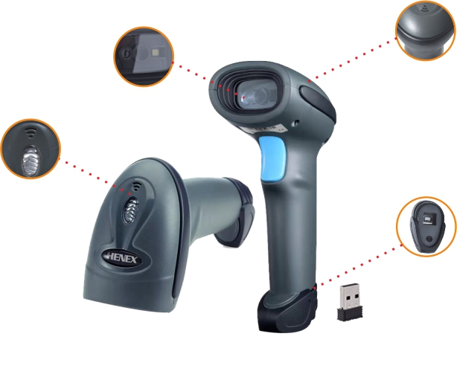
Feature
● With IP54 waterproof and dustproof protection.
● Red and Blue Led indicator, buzzer and motor shake.
● Large capacity battery, can continuous use more than 36hours.
● Can set offline inventory mode,the storage capacity is 512000bits.
● Using latest decoder technology, can read all 1D and 2D barcodes.
● Ergonomic design, comfortable operating sense,it is not easy to fatigue.
● The air communication distance is 80meters with automatically stored.
● Supports to read screen barcodes, such as mobile phones and computers.
Application area:
Mainly used in commercial,Warehousing, express delivery,Wechatpay,Alipay
Technical Specifications
OPERATIONAL PARAMETER
Image(Pixels) | 640 pixels(H)*480 pixels(v)
Light Source | Aiming:617 nm LED ;illumination:6500K LED
DECODE CAPABILITY | 2D： QR Code, Data Matrix, PDF417,Aztec, Maxicode  1D： UPC/EAN/JAN,UPC-A & UPC-E,EAN-8 & EAN-13, JAN-8 &JAN-13, ISBN/ISSN, Code 39 (with full ASCII), Codabar (NW7), Code 128 & EAN 128,Code 93,Interleaved 2 of 5 (ITF),Addendum 2 of 5, IATA Code,MSI/Plessy, China Postal Code,Code 32 (Italian Pharmacode),RSS 14,RSS Limited, RSS Expanded
Depth of Field | 40-200mm @ UPC/EAN 13mil PCS=90%；20-250mm @ QR 20mil PCS=100%
Scan Angle | Elevation angle 65°/Tilt angle 30°/Declination 55°
Field of view | 34° horizontal, 28° vertical
Minimum Resolution | ≥ 5mil
Print Contrast: | ≥25%
Visual Indicator | Red and blue double colored Led light, Buzzer and motor shake
Communication Method | 2.4G
Communication Distance | 80meters at the open air
Memory | 512000bits
Pair method | One to one
PHYSICAL CHARACTERISTICS
Size | 173mm*67mm*94mm （L*W*H）
Package box size | 220mm*70mm*95mm （L*W*H）
Weight | 190g
Charge cable | Standard 1M straight
POWER PARAMETER
Input Voltage | 5VDC±10%
Working Current | 400mA
BATTERY PARAMETER
Capacity | 2200mAh
Charge Method | Use cable for charge
Charge Time | 5h
Working Time | 8h
ENVIRONMENTAL PARAMETER
Operating Temperature | -20℃~+60℃
Working Humidity | 5%~95%non-condensing
Storage Temperature | -40℃~+70℃
Drop Durability | 3 Meters
Light Levels | 0~100,000Lux

