HC-3208
2D Image Barcode Scanner
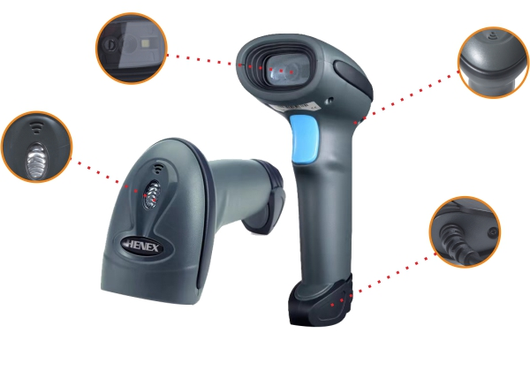
Features
● Plug and play, not need any driver, easy to operate
● Use Complete dust-proof design to meet more applications
● Using latest decoder technology, can read all 1D and 2D barcodes
● Ergonomic design, comfortable operating sense, it is not easy to fatigue
● Supports to read screen barcodes, such as mobile phones and computers
● Widely used in Wechat pay and Alipay, can quickly realize the ID and QR codes
● l Blue LED indicator and loud buzzer sound, can quick feedback reading recods

Application area
Mainly used in commerce, health care, tobacco, some industries, etc.
HC-3208 Technical Specifications
Image(Pixels) | 640 pixels(H)*480 pixels(v)
Light Source | Aiming: 617 nm LED; illumination:6500K LED
Scan Angle | Elevation angle 65°/Tilt angle 30°/Declination 55°
Host System Interfaces | TTL-232, USB (HID-KBW, Virtual serial Port)
Print Contrast | More than 25%
Read mode | Manual/Auto sensor
Visual Indicator | Blue LED Lights , Buzzer
DECODE CAPABILITY
1D | 1D： UPC/EAN/JAN,UPC-A & UPC-E, EAN-8 & EAN-13, JAN-8 &JAN-13, ISBN/ISSN, Code 39 (with  full ASCII), Codabar (NW7), Code 128 & EAN 128, Code 93, Interleaved 2 of 5 (ITF),Addendum 2 of  5, IATA Code, MSI/Plessy, China Postal Code,Code 32 (Italian Pharmacode), RSS 14, RSS Limited, RSS  Expanded
2D | 2D： QR Code, Data Matrix, PDF417,Aztec, Maxicode, etc.
PHYSICAL CHARACTERISTICS
Dimension | 173mm*67mm*94mm(L*W*H)
Package Box size | 505mm*460mm*380mm(L*W*H)
Weight | 220g (with cable)
Input Voltage | 5VDC±10%
Working Current | 170mA

